

**Aging in Place Fall Prevention Awareness Day: Stay Independent!**

**Join us** on September 20th, 2024, 10 – noon to learn more about what you can do to protect your independence and mobility. Our interactive event will include speakers and resource on these topics:

|  |  |  |
| --- | --- | --- |
| * Balance Assessments | * How to Reduce Fall Risks | * Fall Risk Checkups |
| * Hearing & Vision | * Safe Exercises | * Brain Health |
| * Technology to Help you Age in Place | * Making your home safer | * MyChart Education |
|  |  |  |
|  |  |  |

**Event Location**: *Long Branch Baptist Church Auditorium 28 Bolt Street, Greenville, SC 29605*

The event is free, but **registration is requested** to plan for lunch.

Registration Link: [September 20th Aging in Place Fall Prevention: Stay Independent Event](https://www.findjoo.com/Agenda/Calendar/7610e888-a390-44cf-9ecb-a5ec014d6bd7?calendarType=2&inlineLayout=true&includeHeader=false)

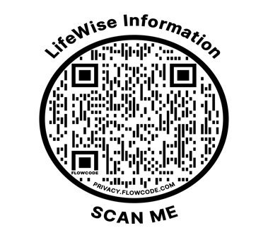

If you have event questions, call Susan Cannon, LifeWise Program Coordinator, 864.292.9691 or email susan_cannon@bshsi.org.